Haidy Essam Mostafa Elhamady

Lab1

Using sed utility

**1- Display the lines that contain the word “lp” in /etc/passwd file.**

**sed -n '/lp/p' /etc/passwd**

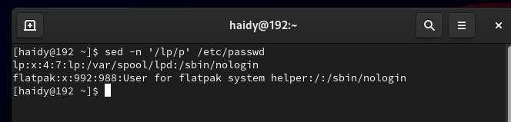

**2-Display /etc/passwd file except the third line.**

**sed '3d' /etc/passwd**

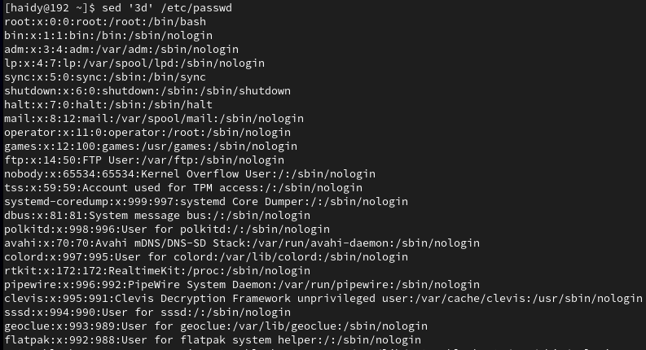

**3- Display /etc/passwd file except the last line.**

**sed '$d' /etc/passwd**

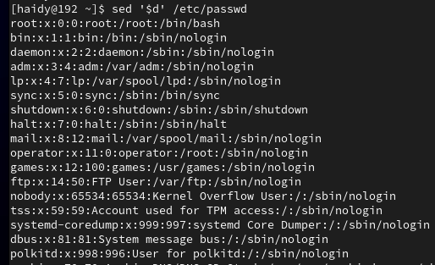

**4-Display /etc/passwd file except the lines that contain the word “lp”.**

**sed '/lp/d' /etc/passwd**

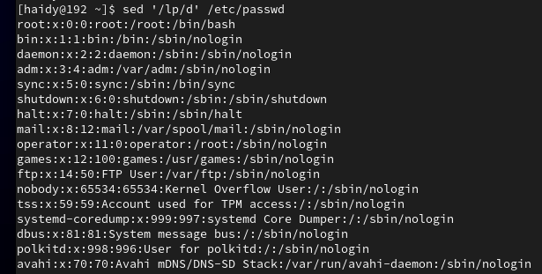

**5- Substitute all the words that contain “lp” with “mylp” in /etc/passwd file.**

**sed 's/lp/mylp/g' /etc/passwd**

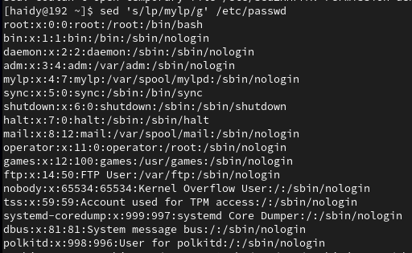

**Using awk utility**

**1-Print full name (comment) of all users in the system.**

**awk -F':' '{print $5}' /etc/passwd**

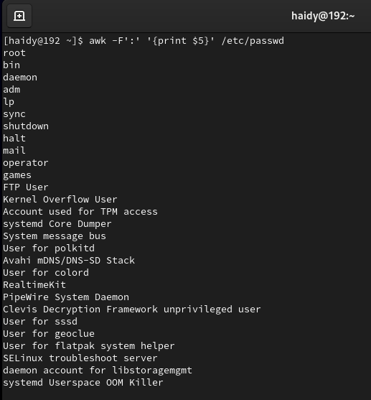

**2-Print login, full name (comment) and home directory of all users.( Print each line preceded by a line number)**

**awk -F':' '{print NR, $1, $5, $6}' /etc/passwd**

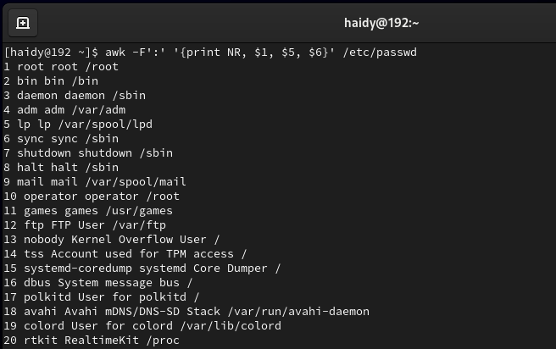

**3-Print login, uid and full name (comment) of those uid is greater than 500**

**awk -F':' '$3 > 500 {print $1, $3, $5}' /etc/passwd**

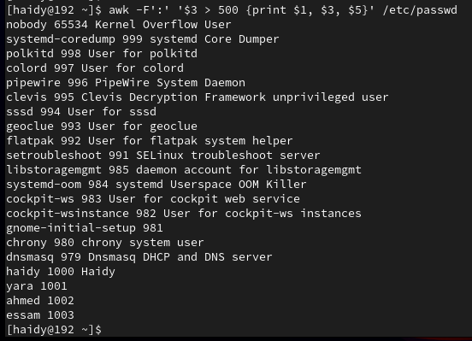

**4-Print login, uid and full name (comment) of those uid is exactly 500**

**awk -F':' '$3 == 500 {print $1, $3, $5}' /etc/passwd**

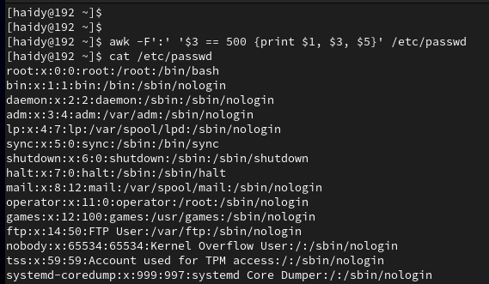

**5- Print line from 5 to 15 from /etc/passwd**

**awk 'NR>=5 && NR<=15' /etc/passwd**

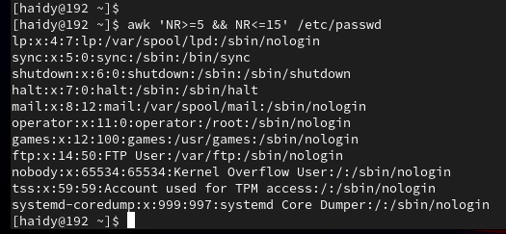

**6- Change lp to mylp**

**awk '{sub(/lp/, "mylp"); print}' /etc/passwd**

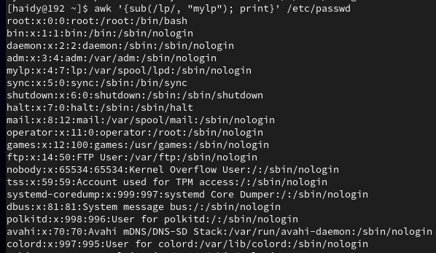

**7- Print all information about greatest uid.**

**awk -F':' '$3 > greatest_id {greatest_id = $3; information = $0} END {print information}' /etc/passwd**



**8- Get the sum of all accounts id’s.**

**awk -F':' '{sum += $3} END { print sum}' /etc/passwd**

